Windows VM SOC Attack Monitoring Lab using Microsoft Sentinel
1. Introduction
This project demonstrates the deployment of a cloud-based Security Operations Center (SOC) lab using Microsoft Azure and Microsoft Sentinel. The objective was to simulate real-world attack activity against a Windows virtual machine, collect security events, enrich them with geolocation data, and visualise attacker behaviour on a global map.
The lab focuses on failed authentication attempts (Event ID 4625), which are commonly associated with brute-force attacks. By integrating Azure Monitor, Log Analytics, and Microsoft Sentinel, this project shows how security analysts can detect, analyse, and visualise threats in a centralized SIEM environment.

2. Lab Architecture Overview
The SOC lab environment consisted of the following components:
- Azure Windows 10 virtual machine exposed to the internet
- Azure Virtual Network and Network Security Group
- Log Analytics Workspace
- Azure Monitor Agent and Data Collection Rule
- Microsoft Sentinel SIEM
- Sentinel Watchlist for GeoIP enrichment
- Sentinel Workbook for attack visualization
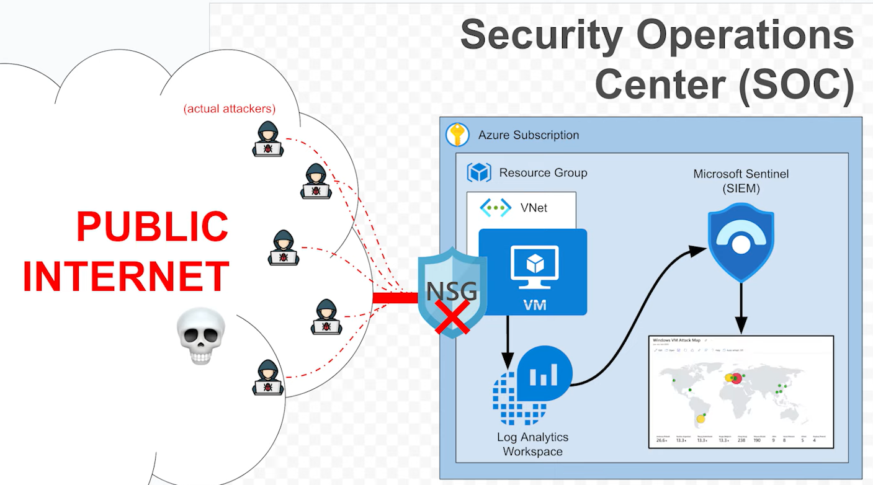

3. Virtual Machine Deployment
A Windows 10 Enterprise virtual machine was deployed in the East US 2 region. The VM was assigned a public IP address to allow inbound RDP traffic. Network Security Group rules were configured to permit RDP access, intentionally exposing the VM to simulate a vulnerable endpoint.
Connectivity to the VM was verified using ICMP ping from the local machine, confirming that the VM was reachable over the internet.
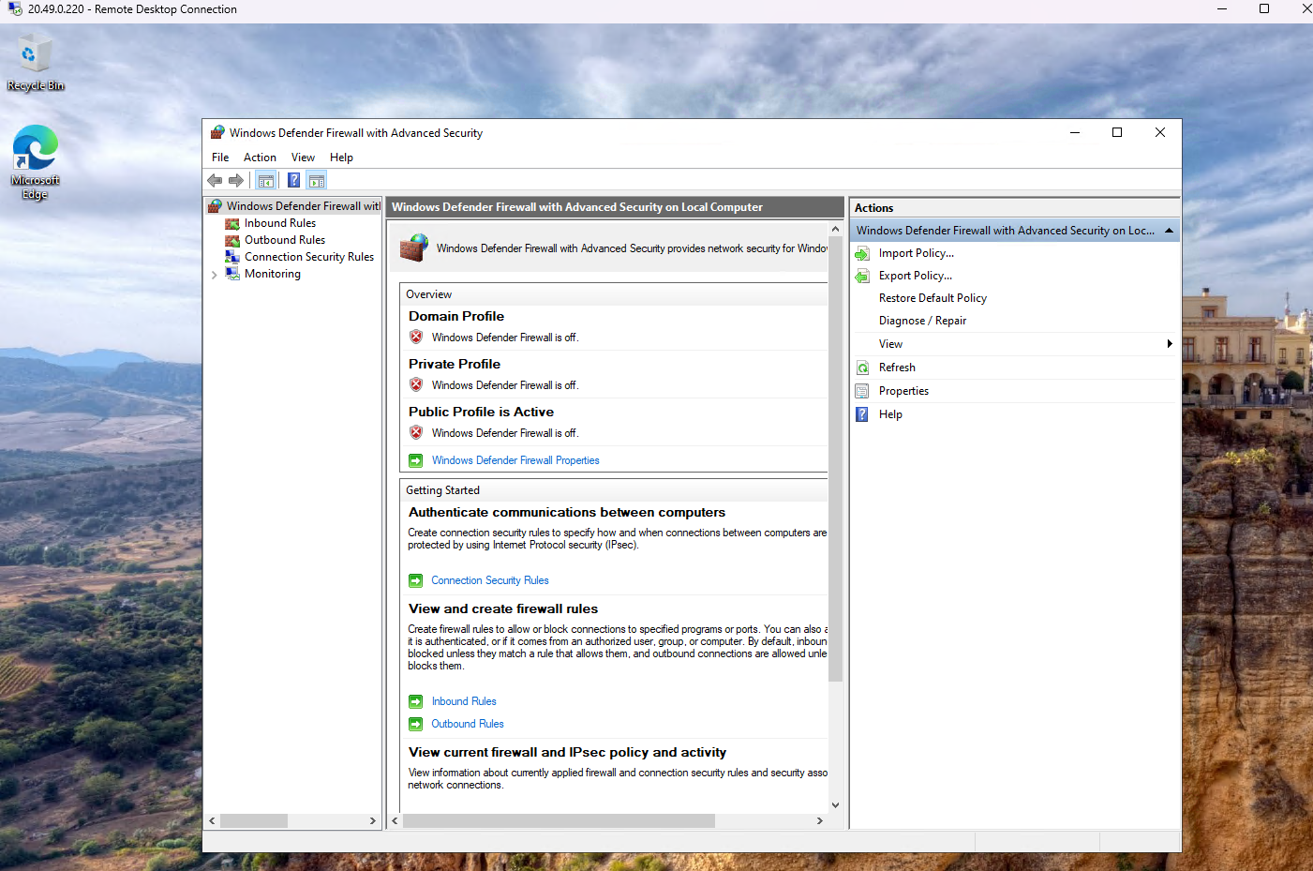

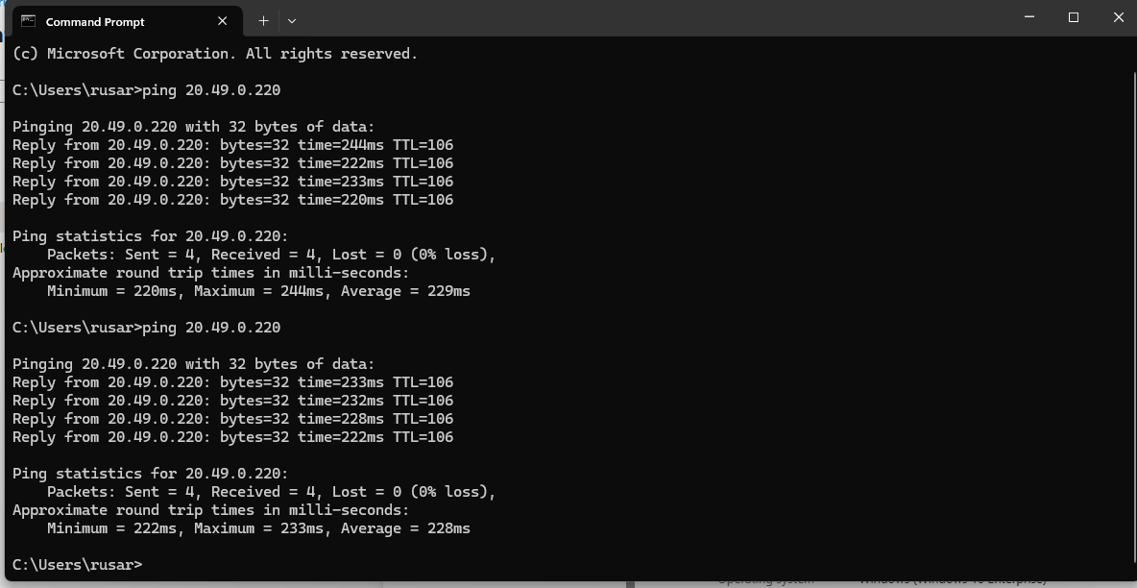

4. Log Analytics Workspace and Azure Monitor Configuration
A Log Analytics Workspace was created and linked to the virtual machine. The Azure Monitor Agent was installed automatically, and a Data Collection Rule was configured to forward Windows Security Event logs to the workspace.
This allowed SecurityEvent logs, including authentication failures, to be centrally collected for analysis.
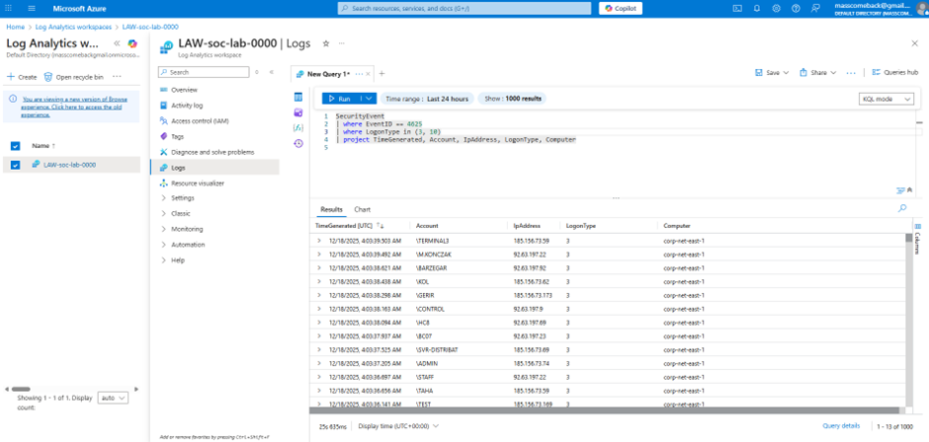

5. Microsoft Sentinel Enablement
Microsoft Sentinel was enabled on the Log Analytics Workspace to provide SIEM capabilities. Once enabled, Sentinel began ingesting security events from the connected VM.
This step established the foundation for querying, threat detection, and visualisation.
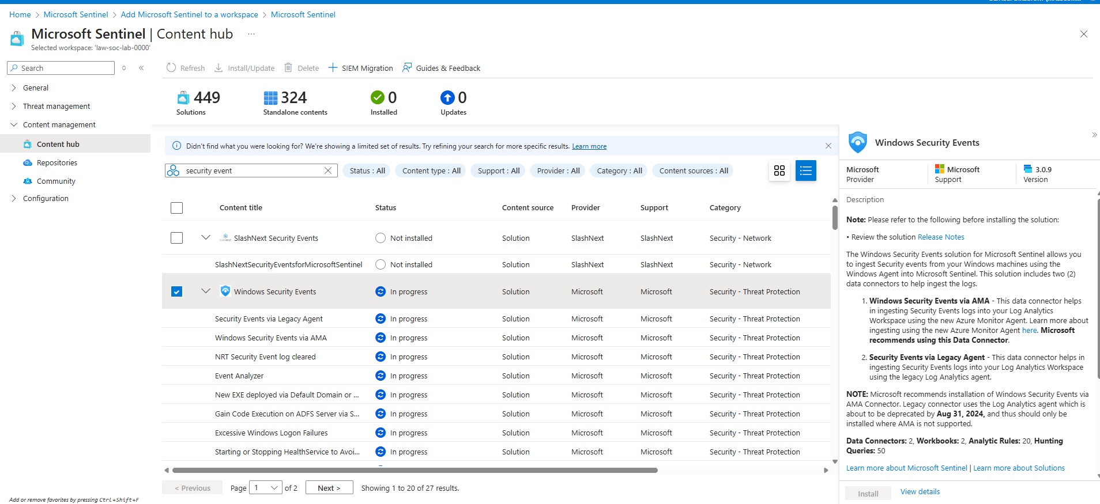
6. Generating and Detecting Failed Login Events
After the VM was exposed, numerous failed login attempts were observed. These attempts originated from multiple external IP addresses and user accounts, indicating automated brute-force behaviour.
Security Event ID 4625 was queried using KQL to identify failed authentication attempts. Initially, some events did not display IP addresses due to log ingestion delay. After sufficient time, IP data became available.
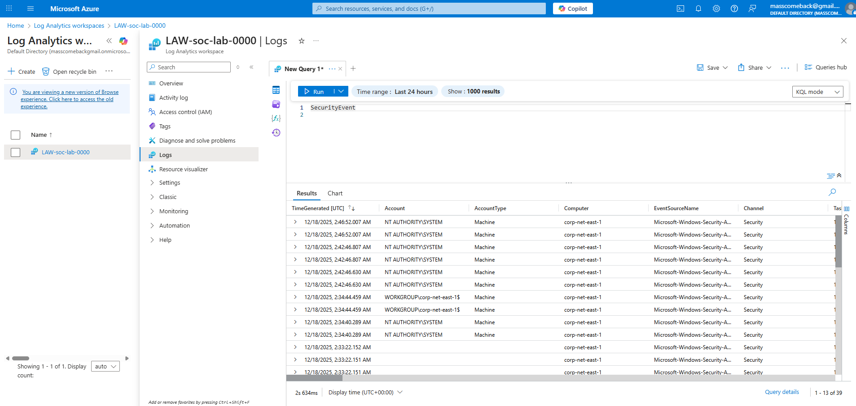

7. KQL Query for Failed Login Analysis
The following KQL query was used to extract failed login events along with source IP addresses and logon types:
SecurityEvent
| where EventID == 4625
| where LogonType in (3, 10)
| project TimeGenerated, Account, IpAddress, LogonType, Computer
This query allowed filtering of network and remote interactive logons, which are commonly targeted during brute-force attacks.
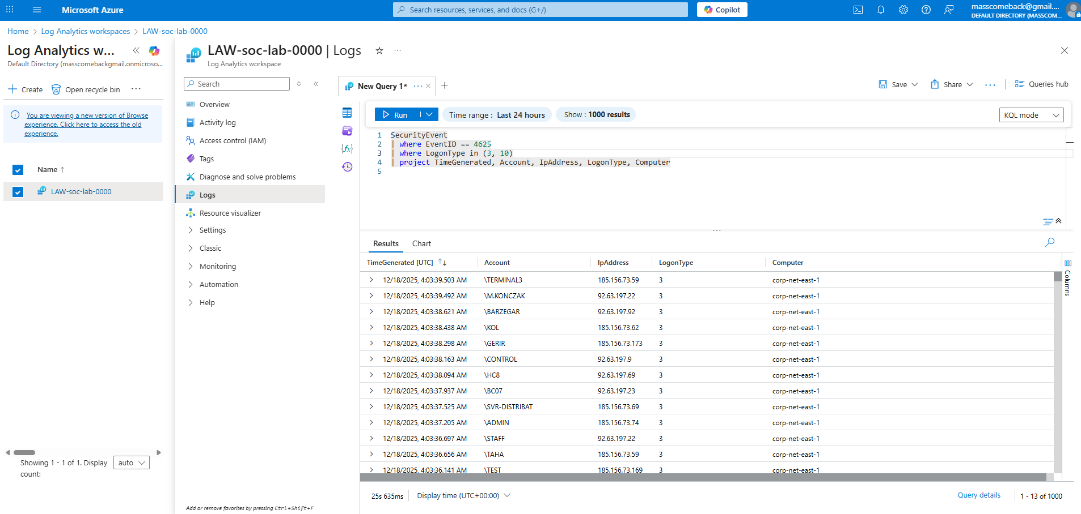
8. GeoIP Enrichment using Sentinel Watchlists
To enrich attacker IP addresses with geographical information, a GeoIP watchlist was created and uploaded into Microsoft Sentinel. The ipv4_lookup function was then used to map IP addresses to countries and cities.
The enrichment query enabled geographical context, which is critical for threat intelligence and incident prioritisation.
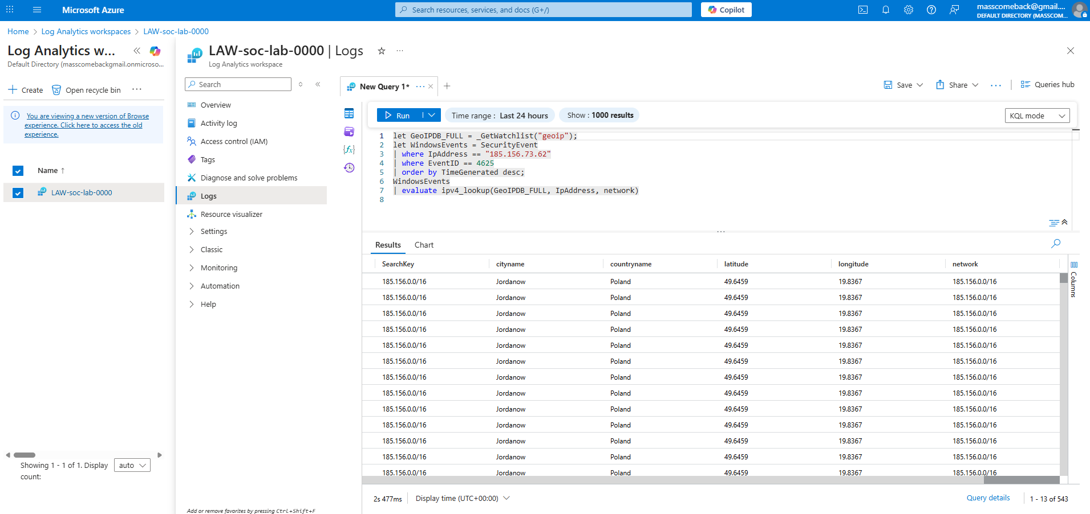
9. Attack Map Visualization using Sentinel Workbook
A Microsoft Sentinel Workbook was created to visualise attack origins on a world map. The workbook plotted failed login attempts by geographic location, with bubble sizes representing attack volume.
This visualization clearly showed concentrated attack sources from multiple countries, demonstrating how Sentinel can provide immediate situational awareness to security analysts.
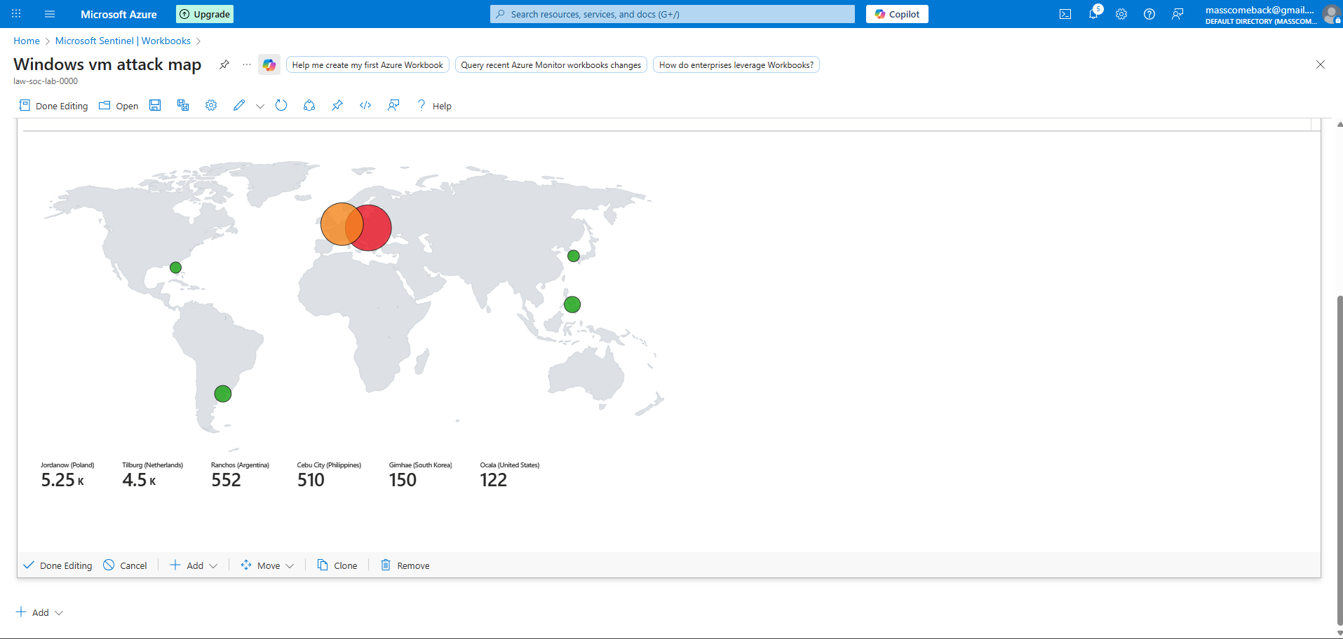
10. Security Findings and Observations
Key observations from the lab include:
- The exposed Windows VM received continuous brute-force login attempts
- Attack traffic originated from multiple global regions
- Event ingestion delays are normal and should be expected in SIEM environments
- GeoIP enrichment significantly improves threat context
- Visual dashboards accelerate analyst decision-making
This behaviour closely mirrors real-world attack patterns observed in enterprise SOCs.

12. Conclusion
This project successfully demonstrated the end-to-end deployment of a cloud-based SOC lab using Microsoft Sentinel. The lab showcased real attack telemetry, log analysis, geolocation enrichment, and threat visualization.
The skills demonstrated in this project are directly applicable to SOC Analyst, Blue Team, and Cloud Security roles, including SIEM deployment, KQL querying, threat analysis, and incident visualization.

